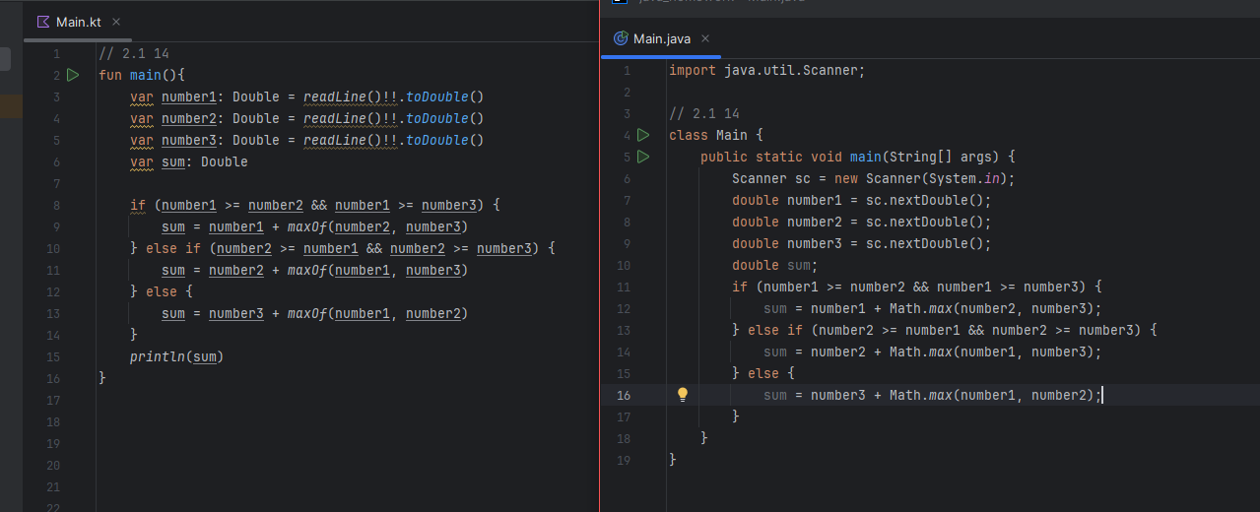

// 2.1 14  
fun main(){  
 var number1: Double = *readLine*()!!.*toDouble*()  
 var number2: Double = *readLine*()!!.*toDouble*()  
 var number3: Double = *readLine*()!!.*toDouble*()  
 var sum: Double  
  
 if (number1 >= number2 && number1 >= number3) {  
 sum = number1 + *maxOf*(number2, number3)  
 } else if (number2 >= number1 && number2 >= number3) {  
 sum = number2 + *maxOf*(number1, number3)  
 } else {  
 sum = number3 + *maxOf*(number1, number2)  
 }  
 *println*(sum)  
}

import java.util.Scanner;  
  
// 2.1 14  
class Main {  
 public static void main(String[] args) {  
 Scanner sc = new Scanner(System.*in*);  
 double number1 = sc.nextDouble();  
 double number2 = sc.nextDouble();  
 double number3 = sc.nextDouble();  
 double sum;  
 if (number1 >= number2 && number1 >= number3) {  
 sum = number1 + Math.*max*(number2, number3);  
 } else if (number2 >= number1 && number2 >= number3) {  
 sum = number2 + Math.*max*(number1, number3);  
 } else {  
 sum = number3 + Math.*max*(number1, number2);  
 }

sc.close();  
 }  
}

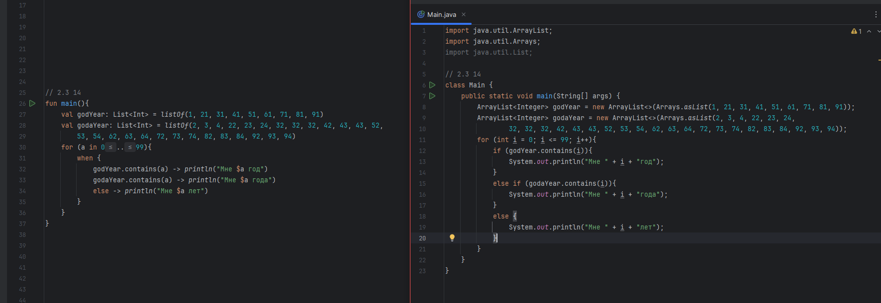

fun main(){  
 val godYear: List<Int> = *listOf*(1, 21, 31, 41, 51, 61, 71, 81, 91)  
 val godaYear: List<Int> = *listOf*(2, 3, 4, 22, 23, 24, 32, 32, 32, 42, 43, 43, 52,  
 53, 54, 62, 63, 64, 72, 73, 74, 82, 83, 84, 92, 93, 94)  
 for (a in 0..99){  
 when {  
 godYear.contains(a) -> *println*("Мне $a год")  
 godaYear.contains(a) -> *println*("Мне $a года")  
 else -> *println*("Мне $a лет")  
 }  
 }  
}

import java.util.ArrayList;  
import java.util.Arrays;  
  
// 2.3 14  
class Main {  
 public static void main(String[] args) {  
 ArrayList<Integer> godYear = new ArrayList<>(Arrays.*asList*(1, 21, 31, 41, 51, 61, 71, 81, 91));  
 ArrayList<Integer> godaYear = new ArrayList<>(Arrays.*asList*(2, 3, 4, 22, 23, 24,  
 32, 32, 32, 42, 43, 43, 52, 53, 54, 62, 63, 64, 72, 73, 74, 82, 83, 84, 92, 93, 94));  
 for (int i = 0; i <= 99; i++){  
 if (godYear.contains(i)){  
 System.*out*.println("Мне " + i + "год");  
 }  
 else if (godaYear.contains(i)){  
 System.*out*.println("Мне " + i + "года");  
 }  
 else {  
 System.*out*.println("Мне " + i + "лет");  
 }  
 }  
 }  
}

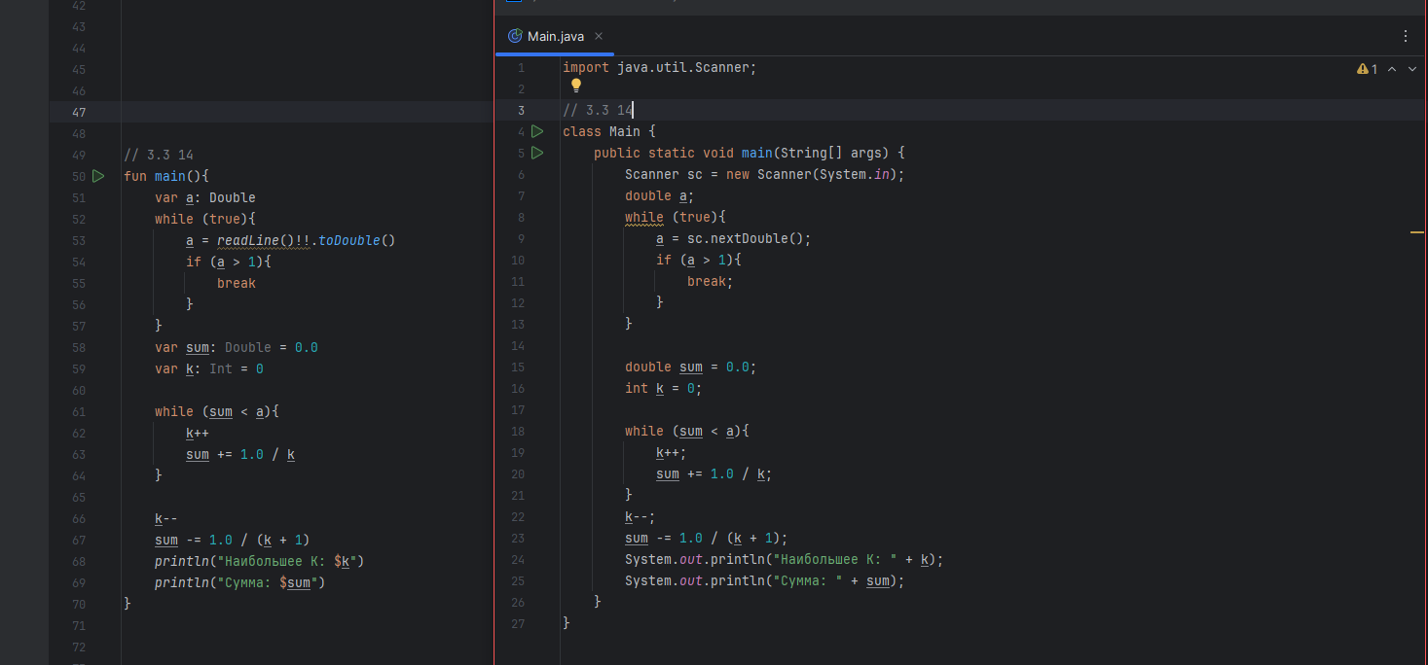

// 3.3 14  
fun main(){  
 var a: Double  
 while (true){  
 a = *readLine*()!!.*toDouble*()  
 if (a > 1){  
 break  
 }  
 }  
 var sum: Double = 0.0  
 var k: Int = 0  
  
 while (sum < a){  
 k++  
 sum += 1.0 / k  
 }  
  
 k--  
 sum -= 1.0 / (k + 1)  
 *println*("Наибольшее K: $k")  
 *println*("Сумма: $sum")  
}

import java.util.Scanner;  
  
// 3.3 14  
class Main {  
 public static void main(String[] args) {  
 Scanner sc = new Scanner(System.*in*);  
 double a;  
 while (true){  
 a = sc.nextDouble();  
 if (a > 1){  
 break;  
 }  
 }  
  
 double sum = 0.0;  
 int k = 0;  
  
 while (sum < a){  
 k++;  
 sum += 1.0 / k;  
 }  
 k--;  
 sum -= 1.0 / (k + 1);  
 System.*out*.println("Наибольшее K: " + k);  
 System.*out*.println("Сумма: " + sum);

sc.close();  
 }  
}

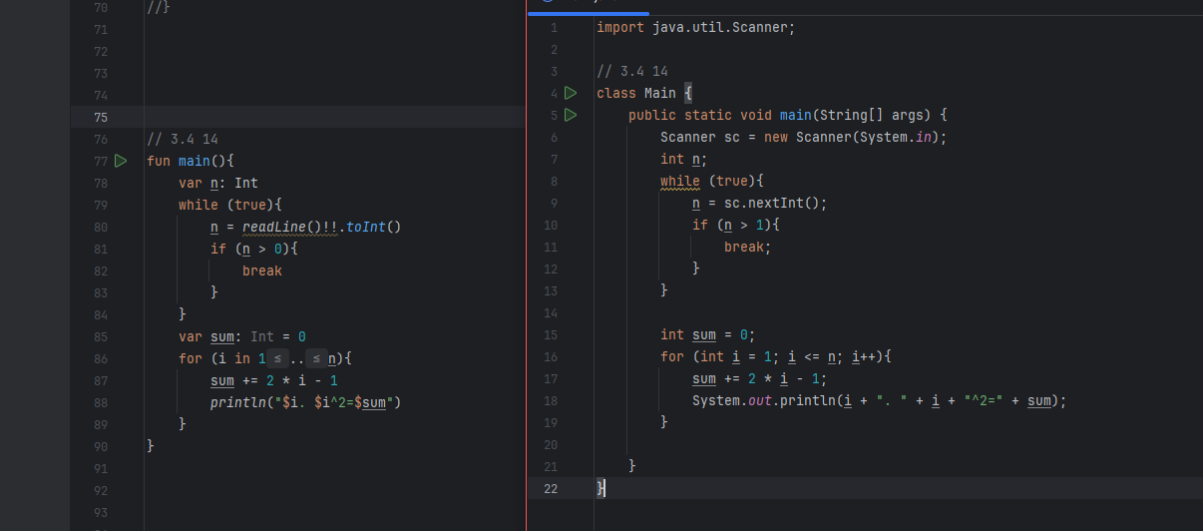

// 3.4 14  
fun main(){  
 var n: Int  
 while (true){  
 n = *readLine*()!!.*toInt*()  
 if (n > 0){  
 break  
 }  
 }  
 var sum: Int = 0  
 for (i in 1..n){  
 sum += 2 * i - 1  
 *println*("$i. $i^2=$sum")  
 }

sc.close();  
}

import java.util.Scanner;  
  
// 3.4 14  
class Main {  
 public static void main(String[] args) {  
 Scanner sc = new Scanner(System.*in*);  
 int n;  
 while (true){  
 n = sc.nextInt();  
 if (n > 1){  
 break;  
 }  
 }  
  
 int sum = 0;  
 for (int i = 1; i <= n; i++){  
 sum += 2 * i - 1;  
 System.*out*.println(i + ". " + i + "^2=" + sum);  
 }  
sc.close();  
 }  
}

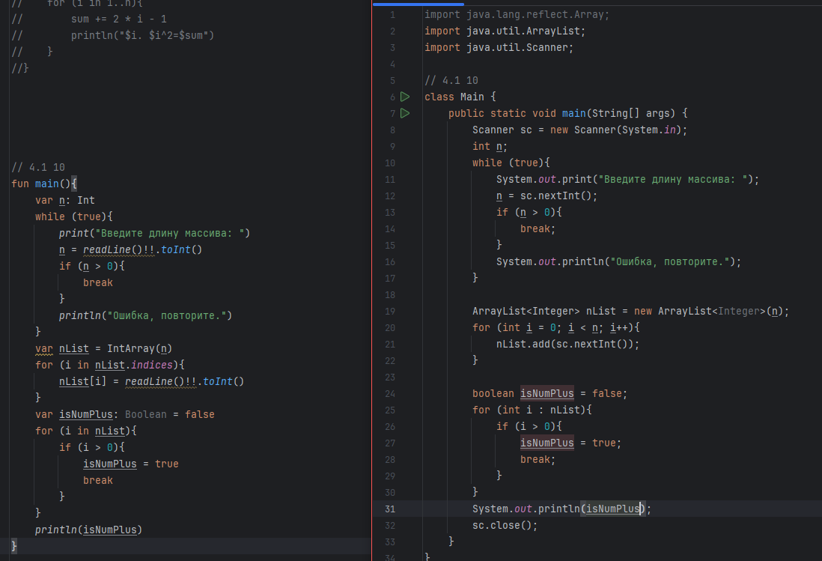

// 4.1 10  
fun main(){  
 var n: Int  
 while (true){  
 *print*("Введите длину массива: ")  
 n = *readLine*()!!.*toInt*()  
 if (n > 0){  
 break  
 }  
 *println*("Ошибка, повторите.")  
 }  
 var nList = IntArray(n)  
 for (i in nList.*indices*){  
 nList[i] = *readLine*()!!.*toInt*()  
 }  
 var isNumPlus: Boolean = false  
 for (i in nList){  
 if (i > 0){  
 isNumPlus = true  
 break  
 }  
 }  
 *println*(isNumPlus)  
}

import java.util.ArrayList;  
import java.util.Scanner;  
  
// 4.1 10  
class Main {  
 public static void main(String[] args) {  
 Scanner sc = new Scanner(System.*in*);  
 int n;  
 while (true){  
 System.*out*.print("Введите длину массива: ");  
 n = sc.nextInt();  
 if (n > 0){  
 break;  
 }  
 System.*out*.println("Ошибка, повторите.");  
 }  
  
 ArrayList<Integer> nList = new ArrayList<Integer>(n);  
 for (int i = 0; i < n; i++){  
 nList.add(sc.nextInt());  
 }  
  
 boolean isNumPlus = false;  
 for (int i : nList){  
 if (i > 0){  
 isNumPlus = true;  
 break;  
 }  
 }  
 System.*out*.println(isNumPlus);  
 sc.close();  
 }  
}

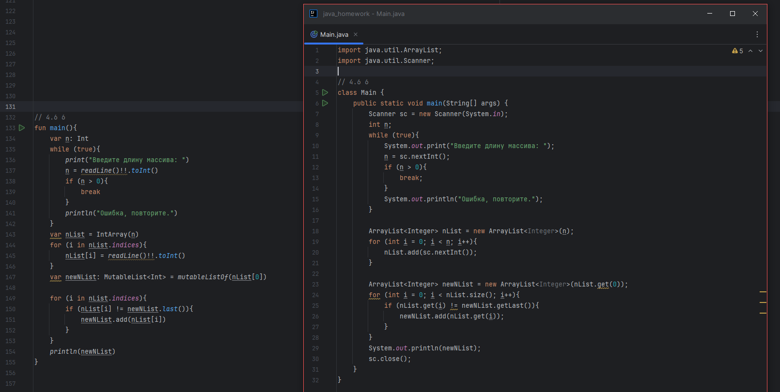

// 4.6 6  
fun main(){  
 var n: Int  
 while (true){  
 *print*("Введите длину массива: ")  
 n = *readLine*()!!.*toInt*()  
 if (n > 0){  
 break  
 }  
 *println*("Ошибка, повторите.")  
 }  
 var nList = IntArray(n)  
 for (i in nList.*indices*){  
 nList[i] = *readLine*()!!.*toInt*()  
 }  
 var newNList: MutableList<Int> = *mutableListOf*(nList[0])  
  
 for (i in nList.*indices*){  
 if (nList[i] != newNList.*last*()){  
 newNList.add(nList[i])  
 }  
 }  
 *println*(newNList)  
}

import java.util.ArrayList;  
import java.util.Scanner;  
  
// 4.6 6  
class Main {  
 public static void main(String[] args) {  
 Scanner sc = new Scanner(System.*in*);  
 int n;  
 while (true){  
 System.*out*.print("Введите длину массива: ");  
 n = sc.nextInt();  
 if (n > 0){  
 break;  
 }  
 System.*out*.println("Ошибка, повторите.");  
 }  
  
 ArrayList<Integer> nList = new ArrayList<Integer>(n);  
 for (int i = 0; i < n; i++){  
 nList.add(sc.nextInt());  
 }  
  
 ArrayList<Integer> newNList = new ArrayList<Integer>(nList.get(0));  
 for (int i = 0; i < nList.size(); i++){  
 if (nList.get(i) != newNList.getLast()){  
 newNList.add(nList.get(i));  
 }  
 }  
 System.*out*.println(newNList);  
 sc.close();  
 }  
}

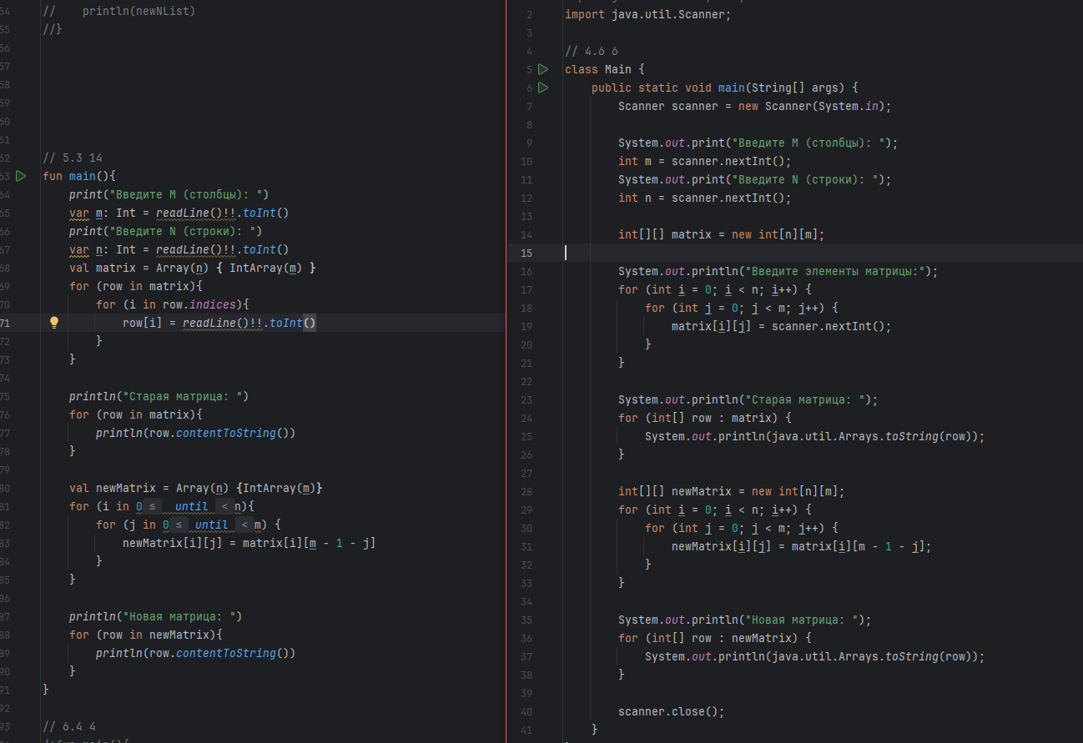

// 5.3 14  
fun main(){  
 *print*("Введите M (столбцы): ")  
 var m: Int = *readLine*()!!.*toInt*()  
 *print*("Введите N (строки): ")  
 var n: Int = *readLine*()!!.*toInt*()  
 val matrix = Array(n) **{** IntArray(m) **}** for (row in matrix){  
 for (i in row.*indices*){  
 row[i] = *readLine*()!!.*toInt*()  
 }  
 }  
  
 *println*("Старая матрица: ")  
 for (row in matrix){  
 *println*(row.*contentToString*())  
 }  
  
 val newMatrix = Array(n) **{**IntArray(m)**}** for (i in 0 *until* n){  
 for (j in 0 *until* m) {  
 newMatrix[i][j] = matrix[i][m - 1 - j]  
 }  
 }  
  
 *println*("Новая матрица: ")  
 for (row in newMatrix){  
 *println*(row.*contentToString*())  
 }  
}

import java.util.Scanner;  
  
// 5.3 14  
class Main {  
 public static void main(String[] args) {  
 Scanner scanner = new Scanner(System.*in*);  
  
 System.*out*.print("Введите M (столбцы): ");  
 int m = scanner.nextInt();  
 System.*out*.print("Введите N (строки): ");  
 int n = scanner.nextInt();  
  
 int[][] matrix = new int[n][m];  
  
 System.*out*.println("Введите элементы матрицы:");  
 for (int i = 0; i < n; i++) {  
 for (int j = 0; j < m; j++) {  
 matrix[i][j] = scanner.nextInt();  
 }  
 }  
  
 System.*out*.println("Старая матрица: ");  
 for (int[] row : matrix) {  
 System.*out*.println(java.util.Arrays.*toString*(row));  
 }  
  
 int[][] newMatrix = new int[n][m];  
 for (int i = 0; i < n; i++) {  
 for (int j = 0; j < m; j++) {  
 newMatrix[i][j] = matrix[i][m - 1 - j];  
 }  
 }  
  
 System.*out*.println("Новая матрица: ");  
 for (int[] row : newMatrix) {  
 System.*out*.println(java.util.Arrays.*toString*(row));  
 }  
  
 scanner.close();  
 }  
}

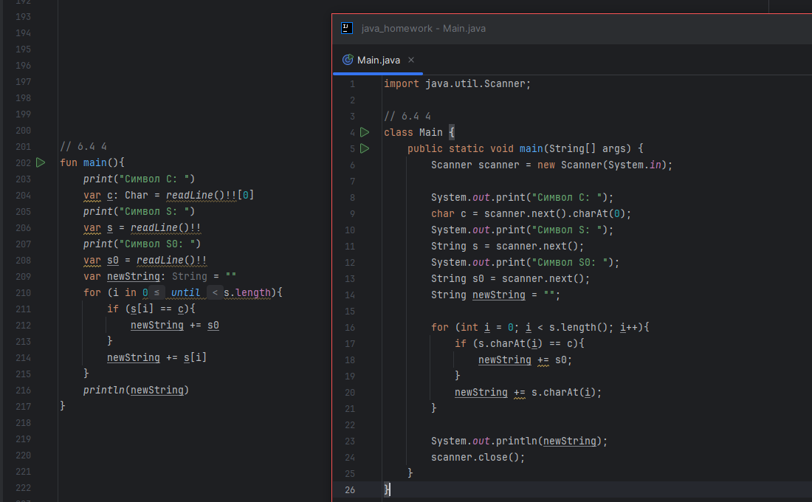

// 6.4 4  
fun main(){  
 *print*("Символ С: ")  
 var c: Char = *readLine*()!![0]  
 *print*("Символ S: ")  
 var s = *readLine*()!!  
 *print*("Символ S0: ")  
 var s0 = *readLine*()!!  
 var newString: String = ""  
 for (i in 0 *until* s.length){  
 if (s[i] == c){  
 newString += s0  
 }  
 newString += s[i]  
 }  
 *println*(newString)  
}

import java.util.Scanner;  
  
// 6.4 4  
class Main {  
 public static void main(String[] args) {  
 Scanner scanner = new Scanner(System.*in*);  
  
 System.*out*.print("Символ С: ");  
 char c = scanner.next().charAt(0);  
 System.*out*.print("Символ S: ");  
 String s = scanner.next();  
 System.*out*.print("Символ S0: ");  
 String s0 = scanner.next();  
 String newString = "";  
  
 for (int i = 0; i < s.length(); i++){  
 if (s.charAt(i) == c){  
 newString += s0;  
 }  
 newString += s.charAt(i);  
 }  
  
 System.*out*.println(newString);  
 scanner.close();  
 }  
}

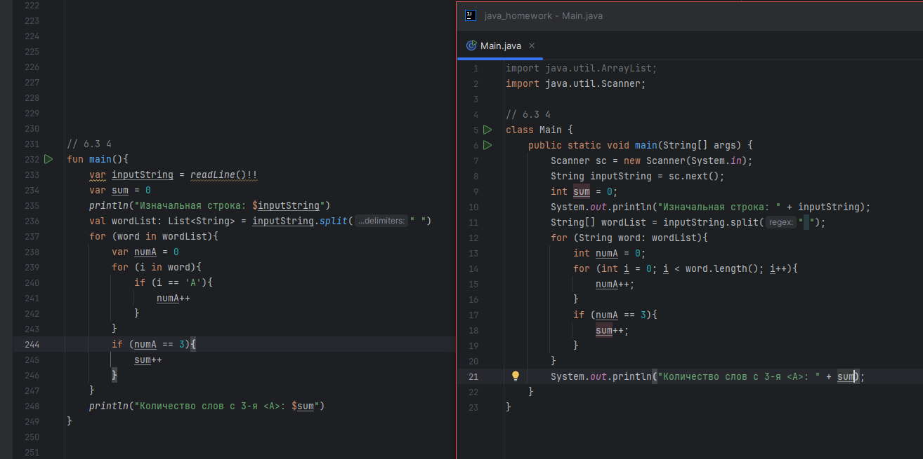

// 6.3 4  
fun main(){  
 var inputString = *readLine*()!!  
 var sum = 0  
 *println*("Изначальная строка: $inputString")  
 val wordList: List<String> = inputString.*split*(" ")  
 for (word in wordList){  
 var numA = 0  
 for (i in word){  
 if (i == 'А'){  
 numA++  
 }  
 }  
 if (numA == 3){  
 sum++  
 }  
 }  
 *println*("Количество слов с 3-я <А>: $sum")  
}

import java.util.Scanner;  
  
// 6.3 4  
class Main {  
 public static void main(String[] args) {  
 Scanner sc = new Scanner(System.*in*);  
 String inputString = sc.next();  
 int sum = 0;  
 System.*out*.println("Изначальная строка: " + inputString);  
 String[] wordList = inputString.split(" ");  
 for (String word: wordList){  
 int numA = 0;  
 for (int i = 0; i < word.length(); i++){  
 numA++;  
 }  
 if (numA == 3){  
 sum++;  
 }  
 }  
 System.*out*.println("Количество слов с 3-я <А>: " + sum);  
 }  
}

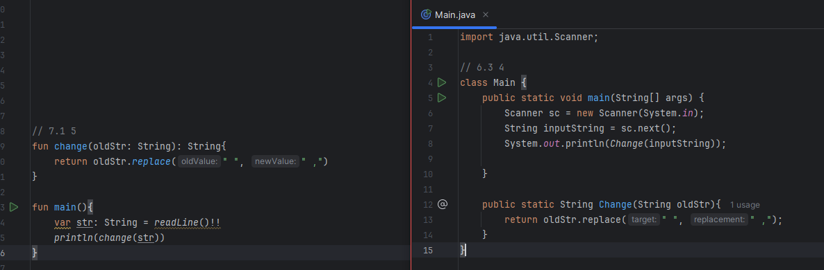

// 7.1 5  
fun change(oldStr: String): String{  
 return oldStr.*replace*(" ", " ,")  
}  
  
fun main(){  
 var str: String = *readLine*()!!  
 *println*(*change*(str))  
}

import java.util.Scanner;  
  
// 7.1 5  
class Main {  
 public static void main(String[] args) {  
 Scanner sc = new Scanner(System.*in*);  
 String inputString = sc.next();  
 System.*out*.println(*Change*(inputString));  
  
 }  
  
 public static String Change(String oldStr){  
 return oldStr.replace(" ", " ,");  
 }  
}

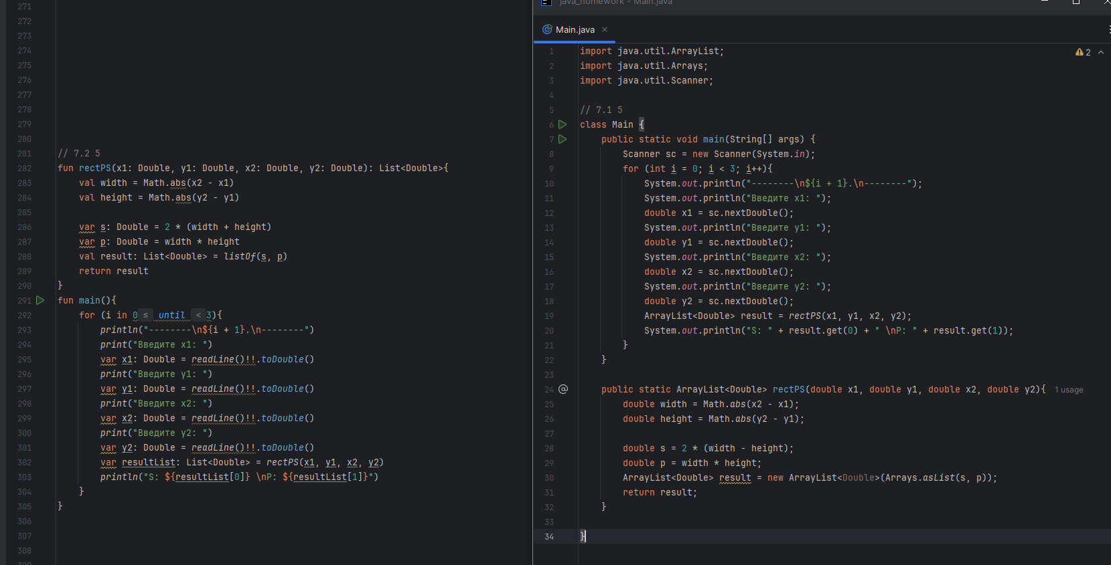// 7.2 5  
fun rectPS(x1: Double, y1: Double, x2: Double, y2: Double): List<Double>{  
 val width = Math.abs(x2 - x1)  
 val height = Math.abs(y2 - y1)  
  
 var s: Double = 2 * (width + height)  
 var p: Double = width * height  
 val result: List<Double> = *listOf*(s, p)  
 return result  
}  
fun main(){  
 for (i in 0 *until* 3){  
 *println*("--------\n${i + 1}.\n--------")  
 *print*("Введите x1: ")  
 var x1: Double = *readLine*()!!.*toDouble*()  
 *print*("Введите y1: ")  
 var y1: Double = *readLine*()!!.*toDouble*()  
 *print*("Введите x2: ")  
 var x2: Double = *readLine*()!!.*toDouble*()  
 *print*("Введите y2: ")  
 var y2: Double = *readLine*()!!.*toDouble*()  
 var resultList: List<Double> = *rectPS*(x1, y1, x2, y2)  
 *println*("S: ${resultList[0]} \nP: ${resultList[1]}")  
 }  
}

import java.util.ArrayList;  
import java.util.Arrays;  
import java.util.Scanner;  
  
// 7.2 5  
class Main {  
 public static void main(String[] args) {  
 Scanner sc = new Scanner(System.*in*);  
 for (int i = 0; i < 3; i++){  
 System.*out*.println("--------\n${i + 1}.\n--------");  
 System.*out*.println("Введите x1: ");  
 double x1 = sc.nextDouble();  
 System.*out*.println("Введите y1: ");  
 double y1 = sc.nextDouble();  
 System.*out*.println("Введите x2: ");  
 double x2 = sc.nextDouble();  
 System.*out*.println("Введите y2: ");  
 double y2 = sc.nextDouble();  
 ArrayList<Double> result = *rectPS*(x1, y1, x2, y2);  
 System.*out*.println("S: " + result.get(0) + " \nP: " + result.get(1));  
 }  
 }  
  
 public static ArrayList<Double> rectPS(double x1, double y1, double x2, double y2){  
 double width = Math.*abs*(x2 - x1);  
 double height = Math.*abs*(y2 - y1);  
  
 double s = 2 * (width - height);  
 double p = width * height;  
 ArrayList<Double> result = new ArrayList<Double>(Arrays.*asList*(s, p));  
 return result;  
 }  
  
}

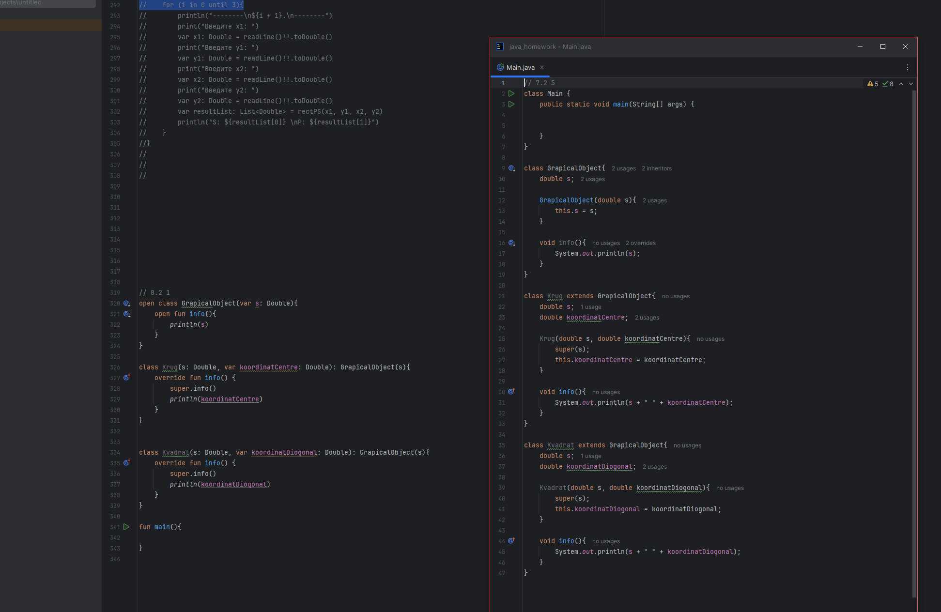

// 8.2 1  
open class GrapicalObject(var s: Double){  
 open fun info(){  
 *println*(s)  
 }  
}  
  
class Krug(s: Double, var koordinatCentre: Double): GrapicalObject(s){  
 override fun info() {  
 super.info()  
 *println*(koordinatCentre)  
 }  
}  
  
  
class Kvadrat(s: Double, var koordinatDiogonal: Double): GrapicalObject(s){  
 override fun info() {  
 super.info()  
 *println*(koordinatDiogonal)  
 }  
}  
  
fun main(){  
  
}

// 8.2 1  
class Main {  
 public static void main(String[] args) {  
  
  
 }  
}  
  
class GrapicalObject{  
 double s;  
  
 GrapicalObject(double s){  
 this.s = s;  
 }  
  
 void info(){  
 System.*out*.println(s);  
 }  
}  
  
class Krug extends GrapicalObject{  
 double s;  
 double koordinatCentre;  
  
 Krug(double s, double koordinatCentre){  
 super(s);  
 this.koordinatCentre = koordinatCentre;  
 }  
  
 void info(){  
 System.*out*.println(s + " " + koordinatCentre);  
 }  
}  
  
class Kvadrat extends GrapicalObject{  
 double s;  
 double koordinatDiogonal;  
  
 Kvadrat(double s, double koordinatDiogonal){  
 super(s);  
 this.koordinatDiogonal = koordinatDiogonal;  
 }  
  
 void info(){  
 System.*out*.println(s + " " + koordinatDiogonal);  
 }  
}